

Travlr Gateways Web Application

CS 465 Project Software Design Document
Version 1.0

Carl LaLonde
5/24/2026

Table of Contents

CS 465 Project Software Design Document 1
Table of Contents 2
Document Revision History 2
Instructions 2
Executive Summary 3
Design Constraints 3
System Architecture View 3
Component Diagram 3
Sequence Diagram 4
Class Diagram 4
API Endpoints 4
The User Interface 4

Document Revision History

Version | Date | Author | Comments
1.0 | 05/24/2026 | Carl LaLonde | Initial software design document for Travlr Getaways web application
1.2 | 06/07/2026 | Carl LaLonde | Updated software design document to include sequence diagram, class diagram, and API endpoint documentation.

Executive Summary

The Travlr Gateways web application will be constructed using the MEAN stack. This includes MongoDB, Express.js, Angular, and Node.js. This full stack web application will be created to support both customers and administrators. The customer side of the application will allow customers to browse travel packages and view information through a responsive website. The administrator side shall be constructed as an SPA or Single Page Application for managing the websites travel package data and updates. Because we are using the MEAN stack, all parts of the application will work together efficiently.

Design Constraints

The Travlr Gateways web application will face a few design constraints. Using the MEAN stack, communication between the web browser, server, and database must work correctly. This application must remain responsive across different devices as well as provide secure administrator access through authentication. These constraints require careful planning, testing, and organization to maintain performance, usability, and security throughout the application.

System Architecture View

Component Diagram

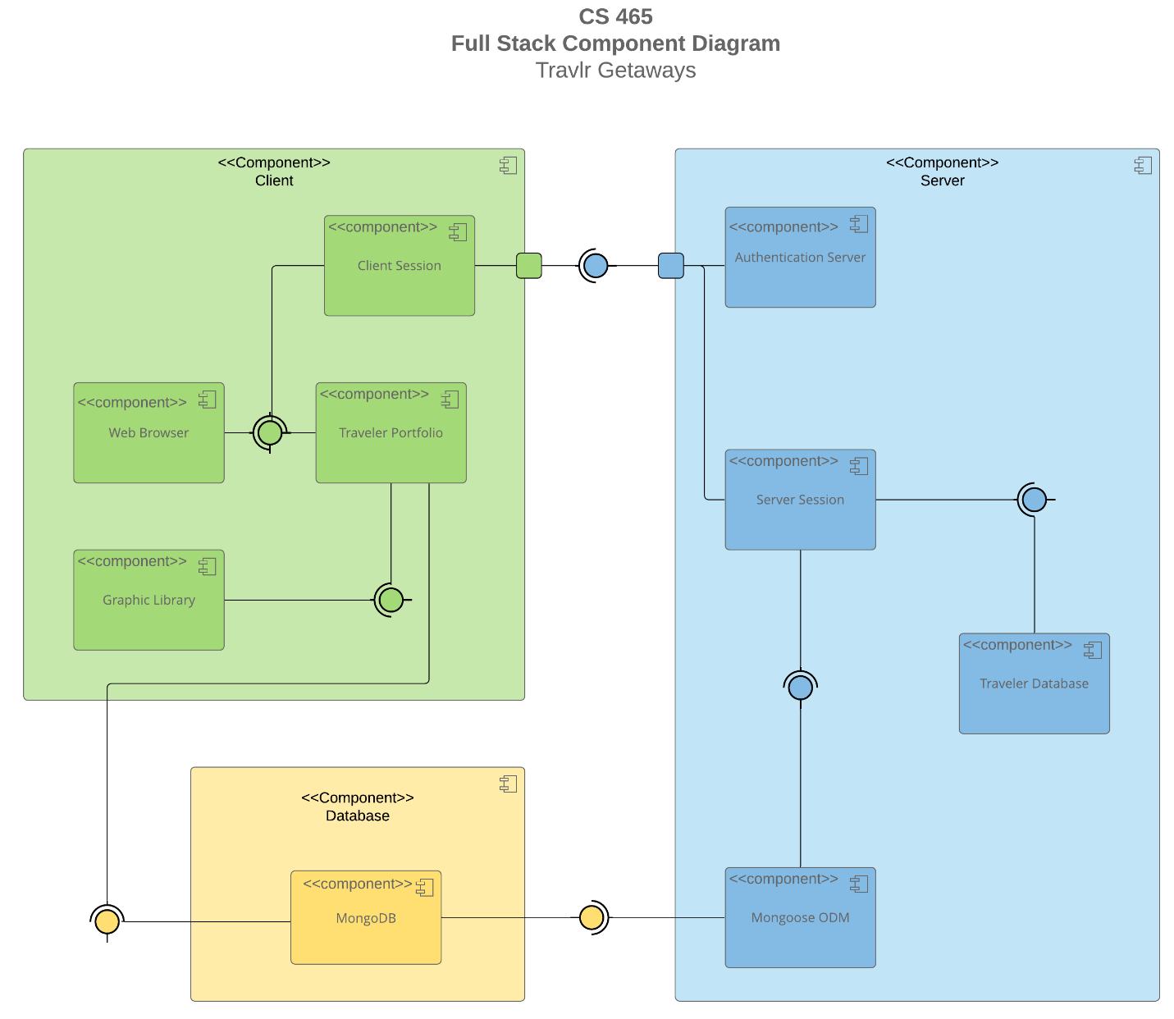

This components diagram shows how the client, server, and database work together within the Travlr Gateways web application. The client side includes the web browser and an Angular frontend application, which communicates with the server to request and display travel information. The server handles authentication, user sessions and request processing through Node.js and Express.js. At the same time, MongoDB stores the applications data. Mongoose ODM is used to connect the server to the database, which helps to manage data more efficiently. This architecture separates responsibilities between frontend, server, and database to create an organized and maintainable system.

Sequence Diagram

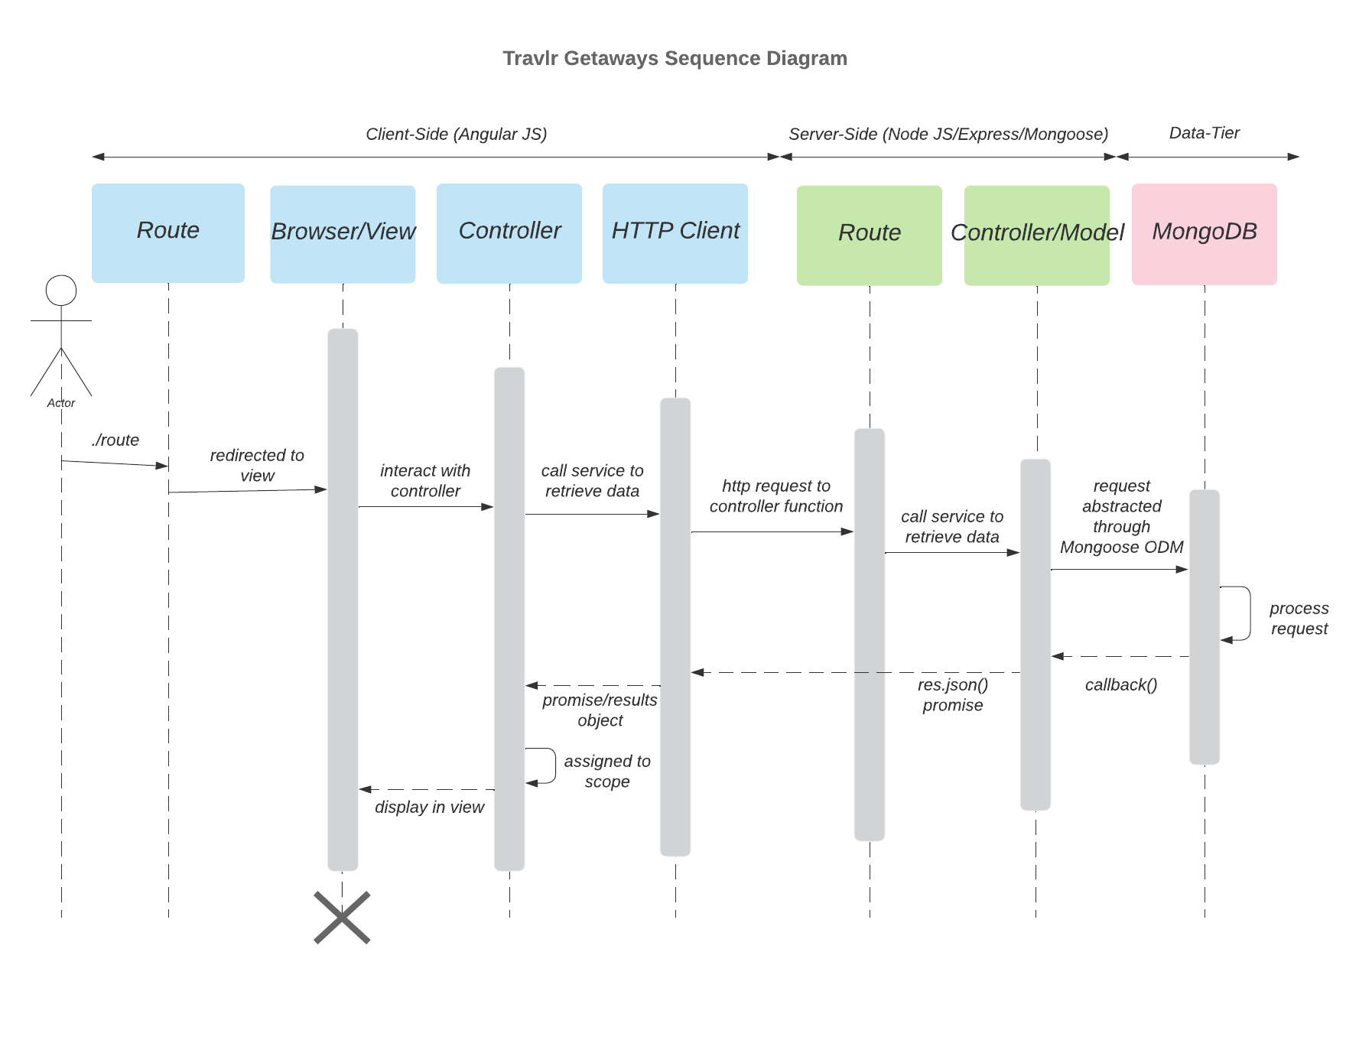

This sequence diagram shows the flow of data through the Travlr Getaways web application. The user will access a route through the browser, which will then load the appropriate view template. The Controller requests data through the HTTP Client, which in turn sends an API request to the Express route on the server. The route then forwards the request to the controller/model layer, where Mongoose communicates with MongoDB to retrieve the trip data. The database returns the requested data and is sent back through the controller and route as a JSON response. The client will receive the response, connect the data to the view and display the requested information to the user.

Class Diagram

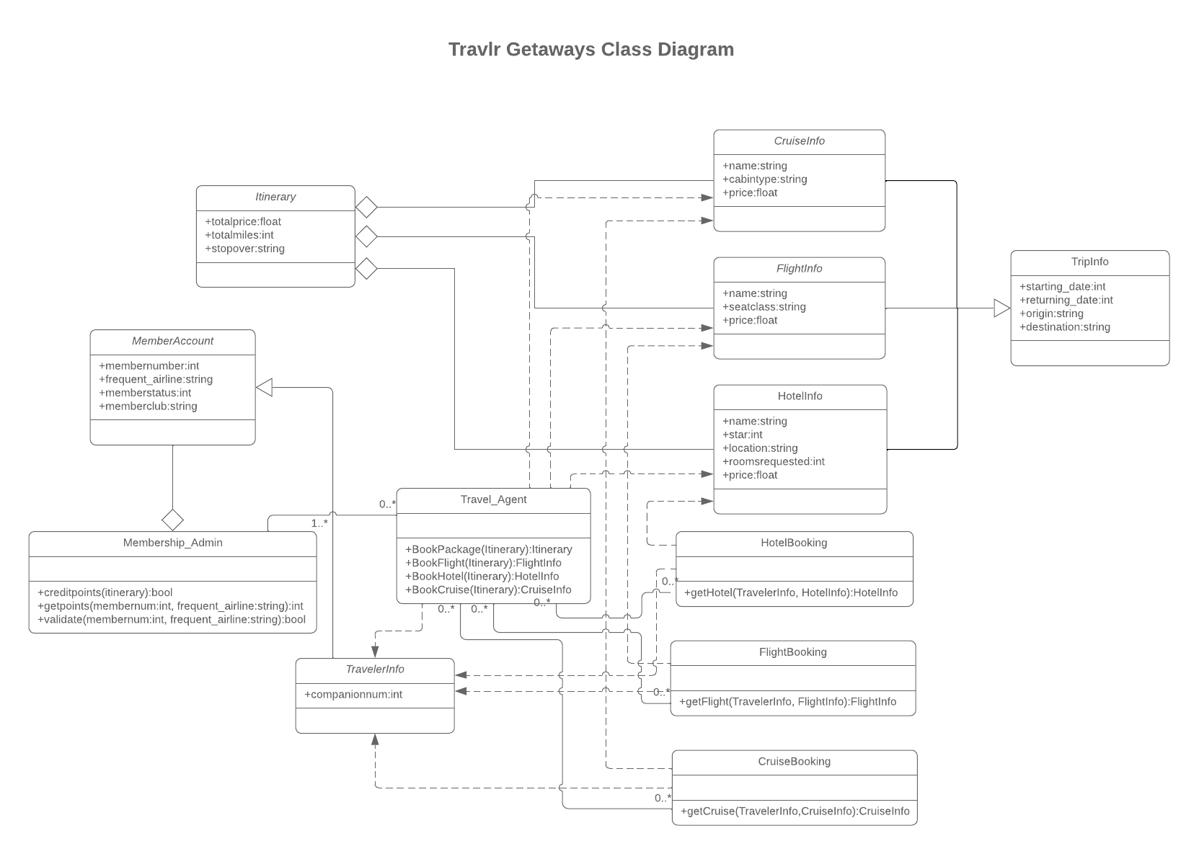
The class diagram displays the primary classes used within the Travlr Getaways web application and the relationships between them. The Itinerary class stores a summary of some travel information such as the total price, total miles, and any stopovers. The Itinerary is composed of CruiseInfo, FlightInfo, and HotelInfo, each containing details about the travel accommodations, transportation, and price. TripInfo is associated with CruiseInfo, FlightInfo, and HotelInfo and stores overall trip information such as starting date, ending date, place leaving from, and destination.
The Travel_Agent class organizes the booking process by interacting with HotelBooking, FlightBooking, and CruiseBooking which collect information from CruiseInfor, FligthInfo, and HotelInfo classes. The TravelerInfo class stores companion information and is connected to the booking process to provide required details when creating reservations.
MemberAccount contains membership information such as membership number, membership status, membership club, and frequent airline. The MemberAccount class is managed by the Membership_Admin class. Membership_Admin maintains customer records and loyalty program points.

API Endpoints

Method | Purpose | URL | Notes
GET | Retrieve all trips | /api/trips | Returns all trip records from MongoDB database.
GET | Retrieve single trip by trip code | /api/trips/:tripFindByCode | Returns a single trip record based on the trip code.
POST | Create a new trip | /api/trips | Admin user can add new trip to database.
PUT | Update a trip package | /api/trips | Admin user can edit and update trip package details.
DELETE | Delete a trip package | /api/trips/:tripFindByCode | Admin user can delete a trip package from database.

The User Interface

A unique trip added.
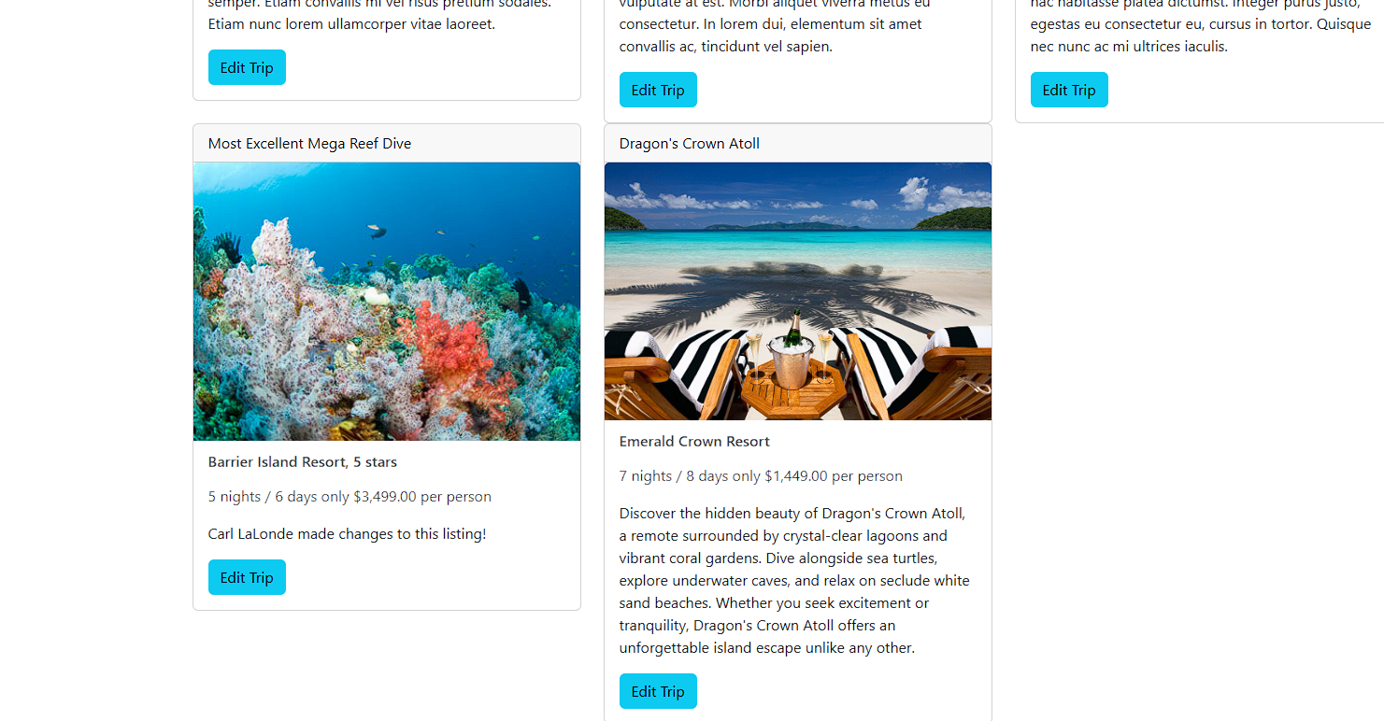

The add trip screen.
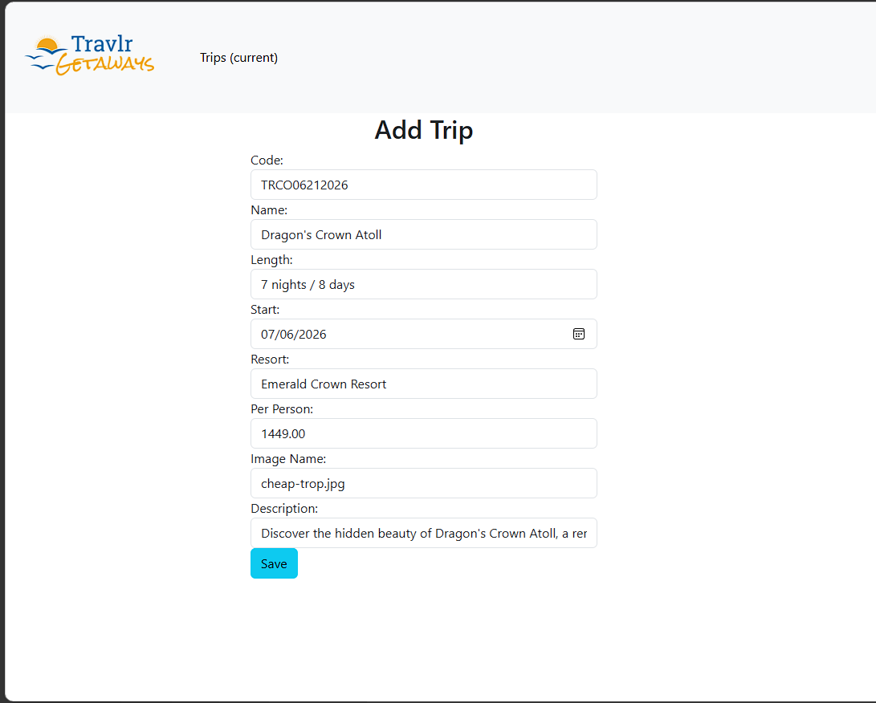

The edit trip screen.
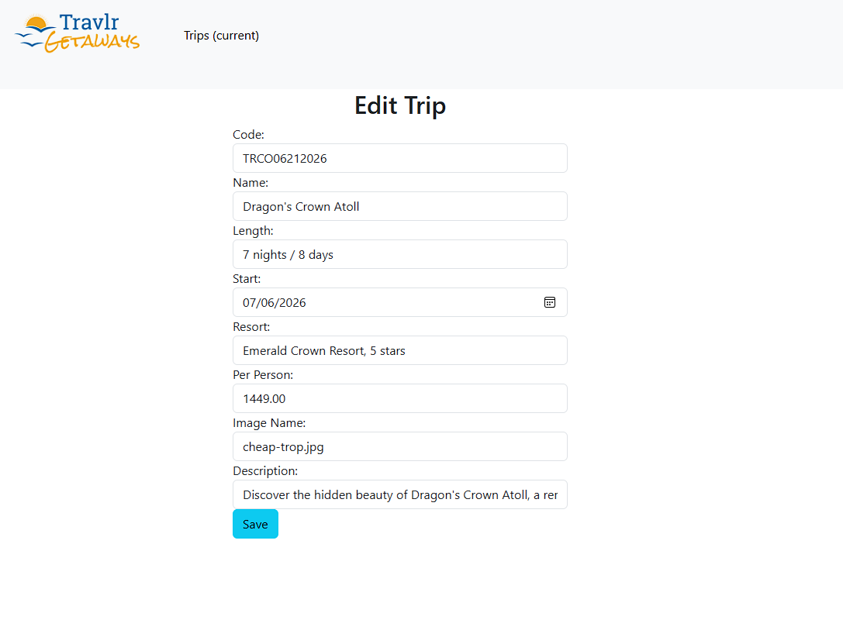

The Angular project is structured as a SPA with separate components, services, routes, and models. These separate components work together to create the user interface and user experience. The Angular project runs in the browser and updates the page dynamically without needing to do a full page reload. The Express project renders pages through the server-side routes. Also, Express provides backend APIs, connects to MongoDB, and returns the trip data as JSON files. Angular uses the APIs to present data through components such as trip cards.

For testing, I used Postman to verify backend endpoints. I tested using GET to make sure that trip data could be successfully retrieved from MongoDB. Using the POST method, I tested that creating a new trip would record and add the new data to MongoDB. I also tested using the PUT method by updating trip information and verifying that the changes were saved in the database. After confirming the endpoints were functional, I started the Express server and Angular application to verify that the web application could successfully perform CRUD operations through the interface. The trips were loaded correctly, new trips could be added, and existing trips could be edited/updated.

